**Minor Project Report**

**On**

**"Online Tour Booking Website”**

**As A Partial Requirement for the Degree of BACHELOR OF COMPUTER APPLICATION [B.C.A]**

**Submitted to**

**C.B. PATEL COMPUTER COLLEGE**

**J.N.M PATEL SCIENCE COLLEGE SURAT**

**Affiliated To**

**VEER NARMAD SOUTH GUJARAT UNIVERSITY, SURAT (VNSGU)**

**ACADEMIC YEAR 2023-24**

**Internal Guide: Submitted By:**

**Prof. Dr. Vaishali Dindoliwala Neel Vaghasiya (2401).**

Name: Vaghasiya Neel

Seat No: 2401

Class: ty BCA sem 5

Div: 3

Subject: Advance Web Designing

**Index**

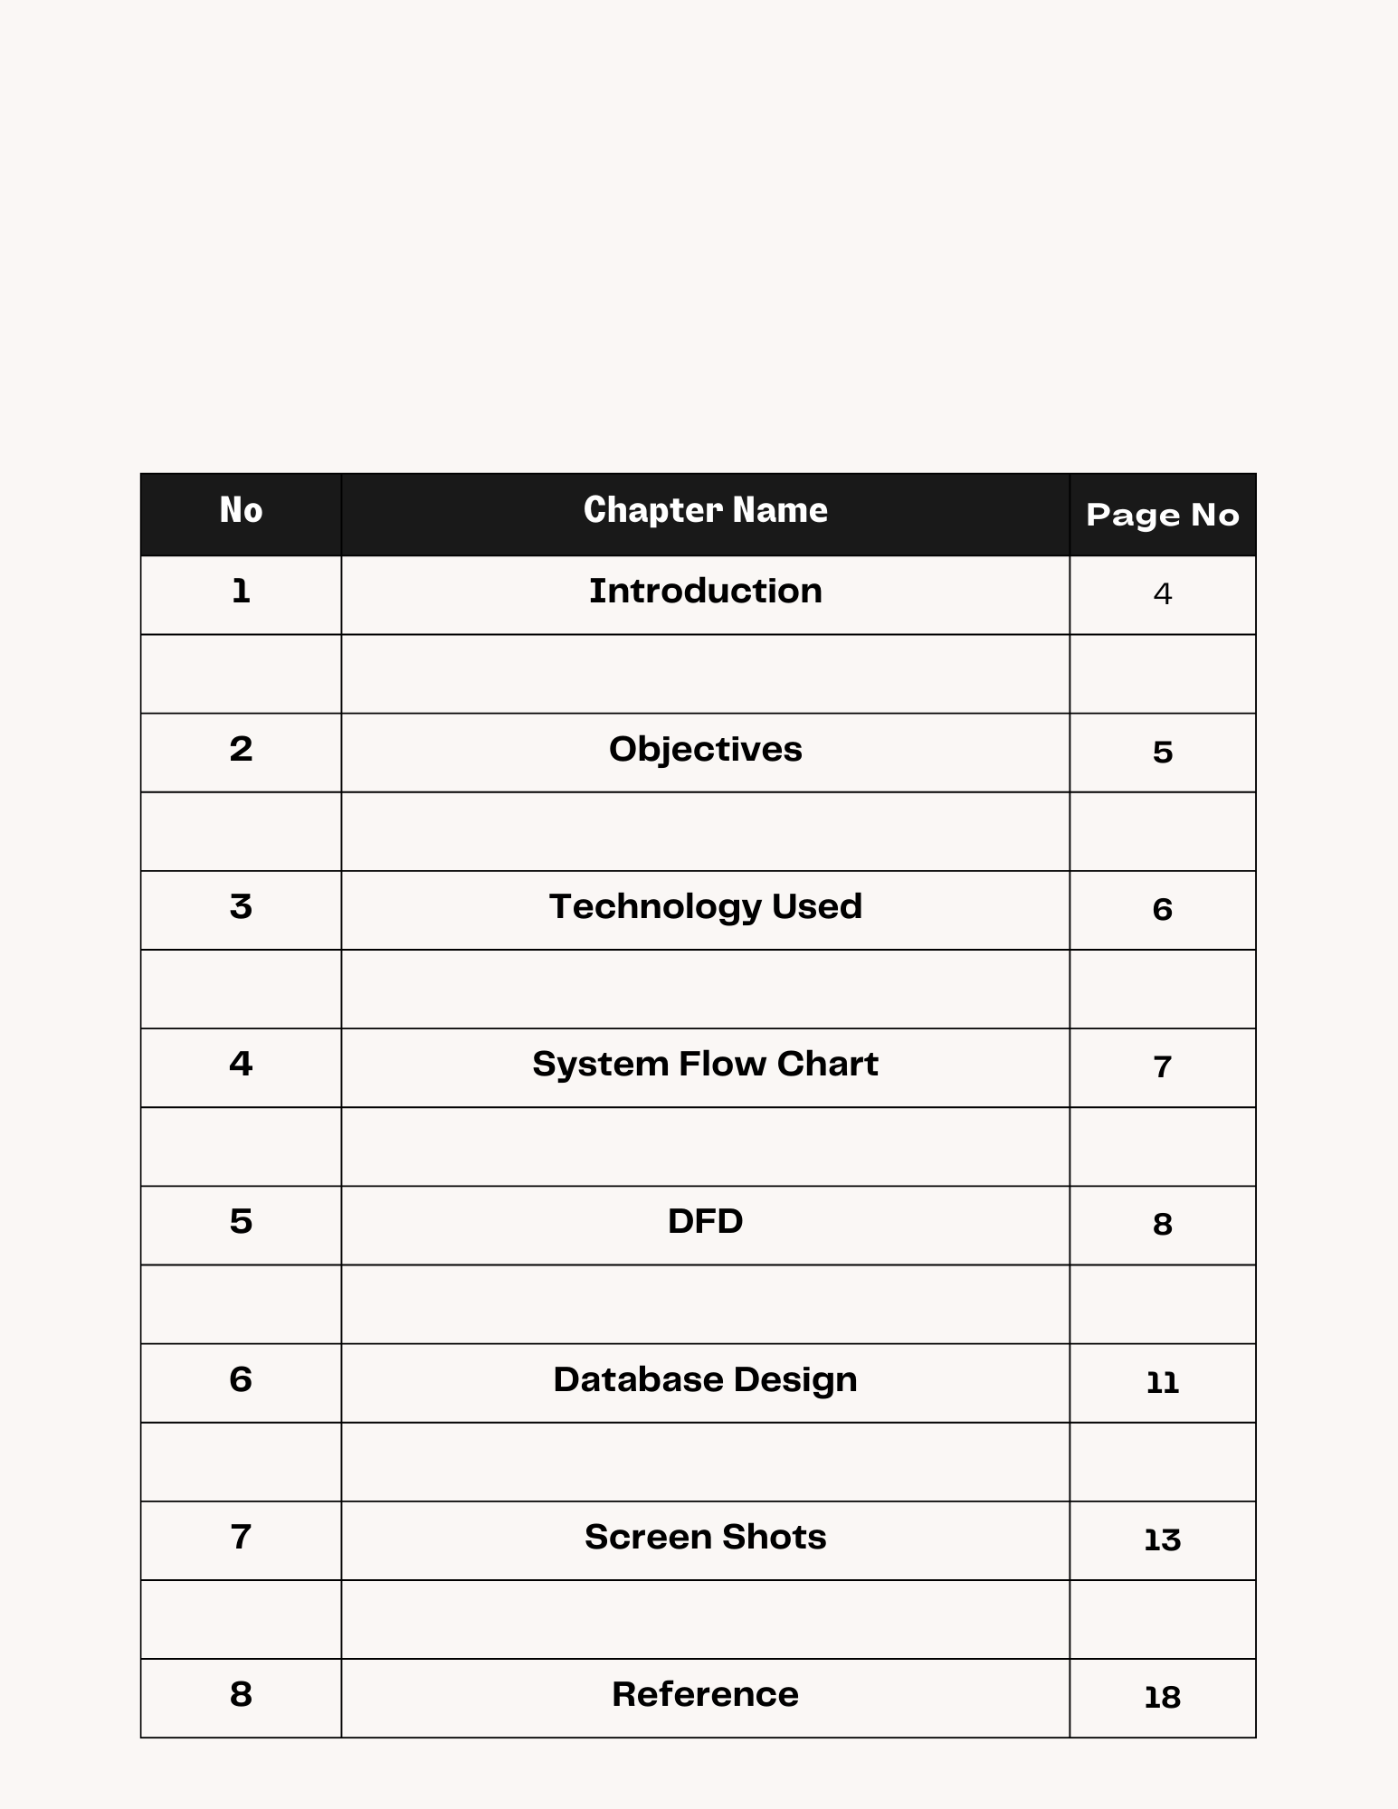

**1.Introduction**

Welcome to the official documentation for Tour! Our online tour booking platform is your gateway to unforgettable travel experiences. Whether you're a traveler planning your next adventure or a developer looking to integrate our services, this documentation will guide you through the features and functionalities of our platform. Discover how [Your Website Name] can simplify the way you explore the world and create lasting memories.

At Tour, we understand the thrill of discovering new places and the joy of embarking on adventures. Our mission is to make travel planning and booking tours an effortless and enjoyable process. With a user-friendly interface and a vast selection of tours and activities, we aim to cater to the diverse interests and preferences of travelers worldwide.

This documentation serves multiple purposes, ensuring that both users and developers can make the most of our platform. For travelers, we provide step-by-step guides on how to navigate our website, search for tours, make bookings, and manage their accounts. Whether you're an experienced globetrotter or a first-time adventurer, our guides are designed to enhance your experience.

**2.Objectives**

The primary objective of Tour is to provide users with a convenient and user-friendly platform for booking tours and experiences at their favorite destinations. Through our website, users can effortlessly register, log in, explore a wide range of curated tour packages, and book their preferred tours.

Our goal is to empower travelers to easily plan and embark on their dream journeys, ensuring a seamless and enjoyable booking experience. We aim to be the go-to platform for individuals seeking hassle-free and memorable travel adventures.

We aspire to be the premier choice for travelers seeking seamless and convenient tour bookings. Our objective is to offer a one-stop solution that caters to the unique preferences and interests of each user.

Whether it's exploring exotic destinations, embarking on cultural adventures, or indulging in thrilling outdoor activities, our platform is designed to connect users with the experiences that match their desires, all within a few clicks.

In line with our mission, we prioritize user satisfaction and aim to exceed expectations at every turn. We recognize that travelers have varying needs and budgets, and we are committed to providing options that accommodate these diverse requirements.

**Technology Used:**

**Front End:**

1.HTML

2.CSS

3.Javascript

4.Bootstrap

5.PHP

**Backend:**

MySQL

**3.System Flow Chart**

Start

Admin

User

Login

No

Register

Login

Yes

Search Tour

Add User

View Tour

Add Product

Book Tour

No

Manage Booked Tour

Book Now Form

Tour Booked

Logout

**4.DFD**

**Zero level**

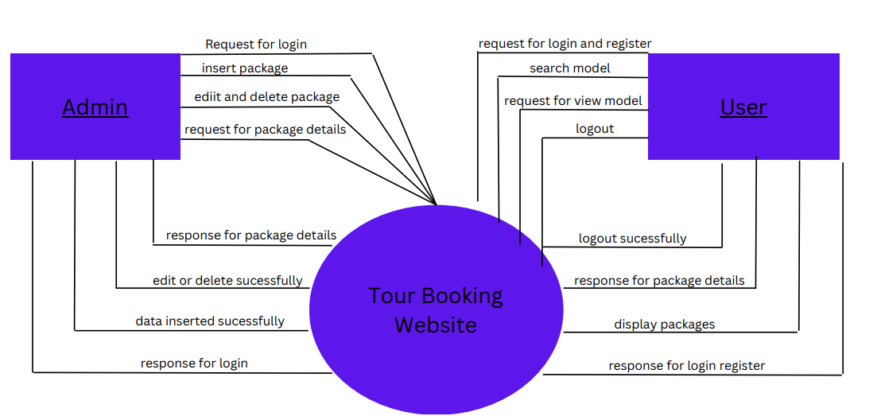

**First Level**

response

pup2.3 update product

request product updated

MYSQL

Admin

request delete

response product deleted

request Product add

response product added

### **First Level**

Login details

Login Details

Request Response

1User Login

MYSQL

9.0 Manage Profile

Package details

package Details

2

Book package

User

Request Response

book package

**5. Database design**

Admin table

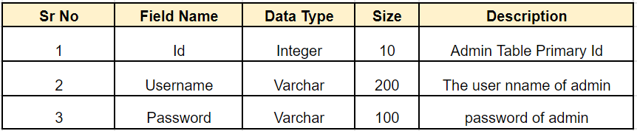

Book Now Table:

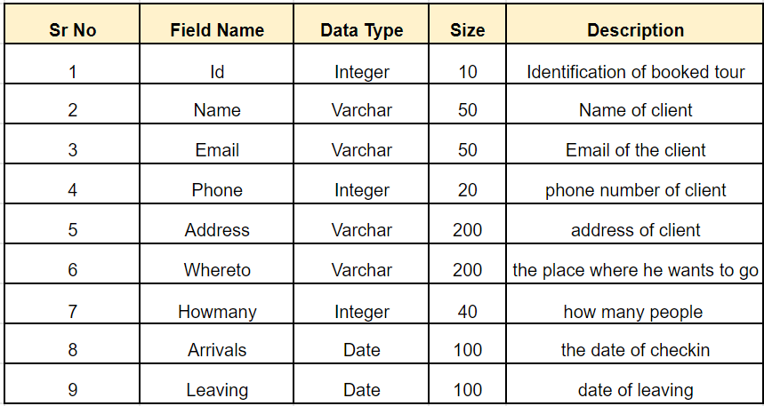

Package table:

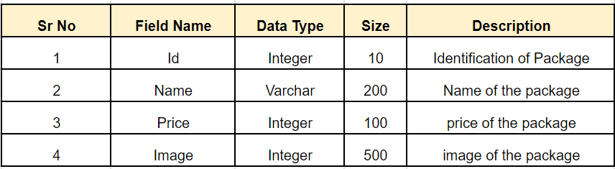

Register table:

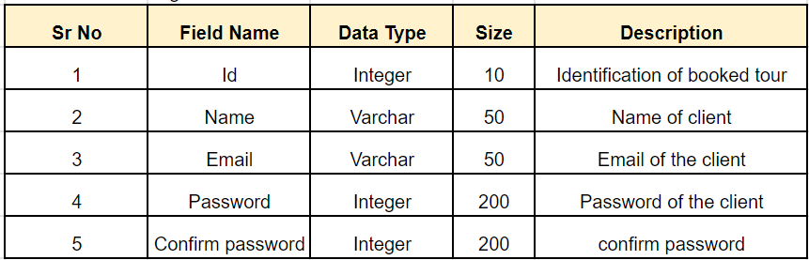

6. Screen Shots

Admin & User

Register and login page:  
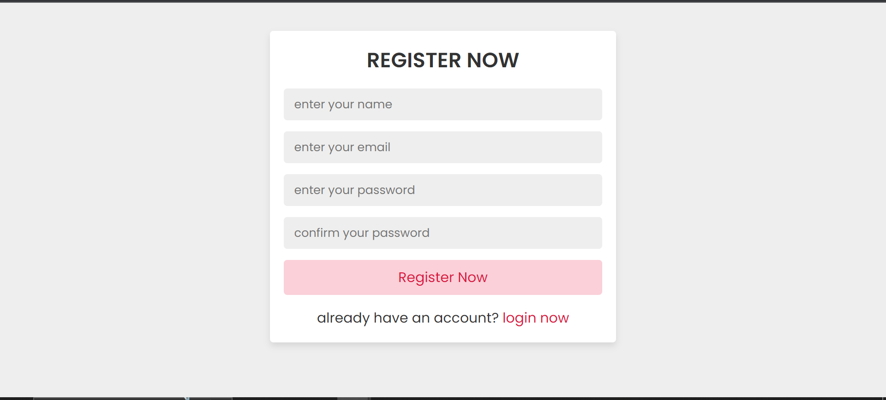

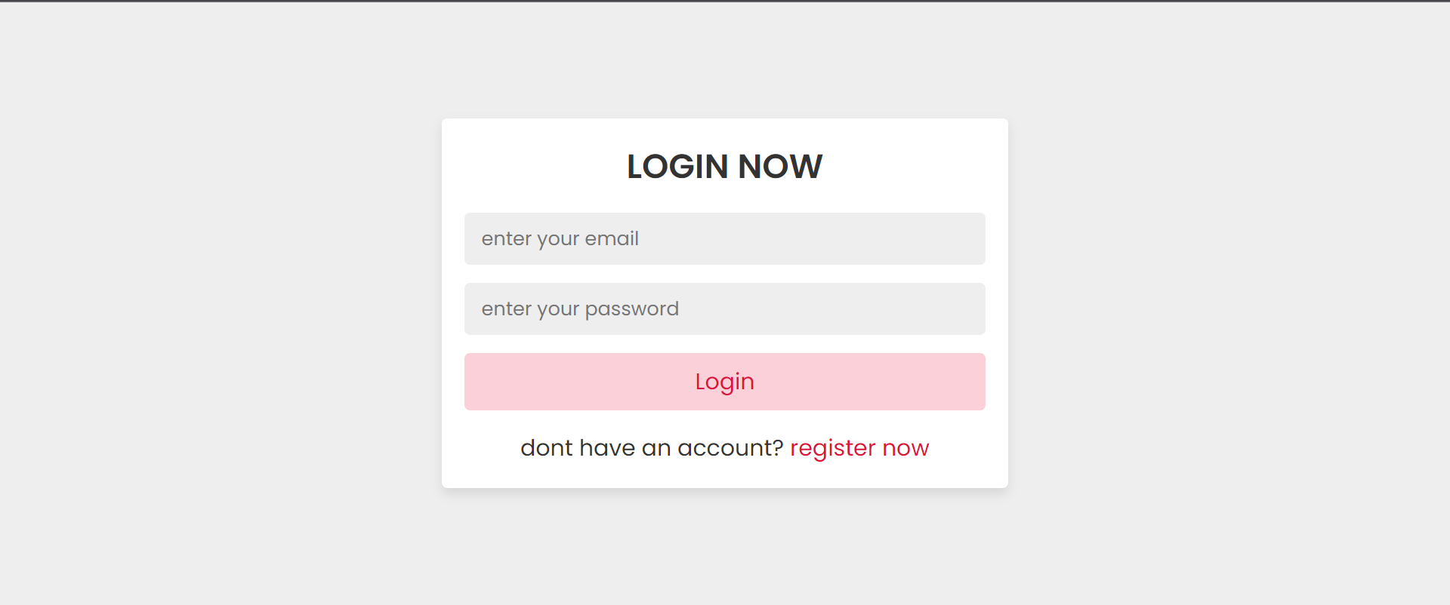

Admin Home page:

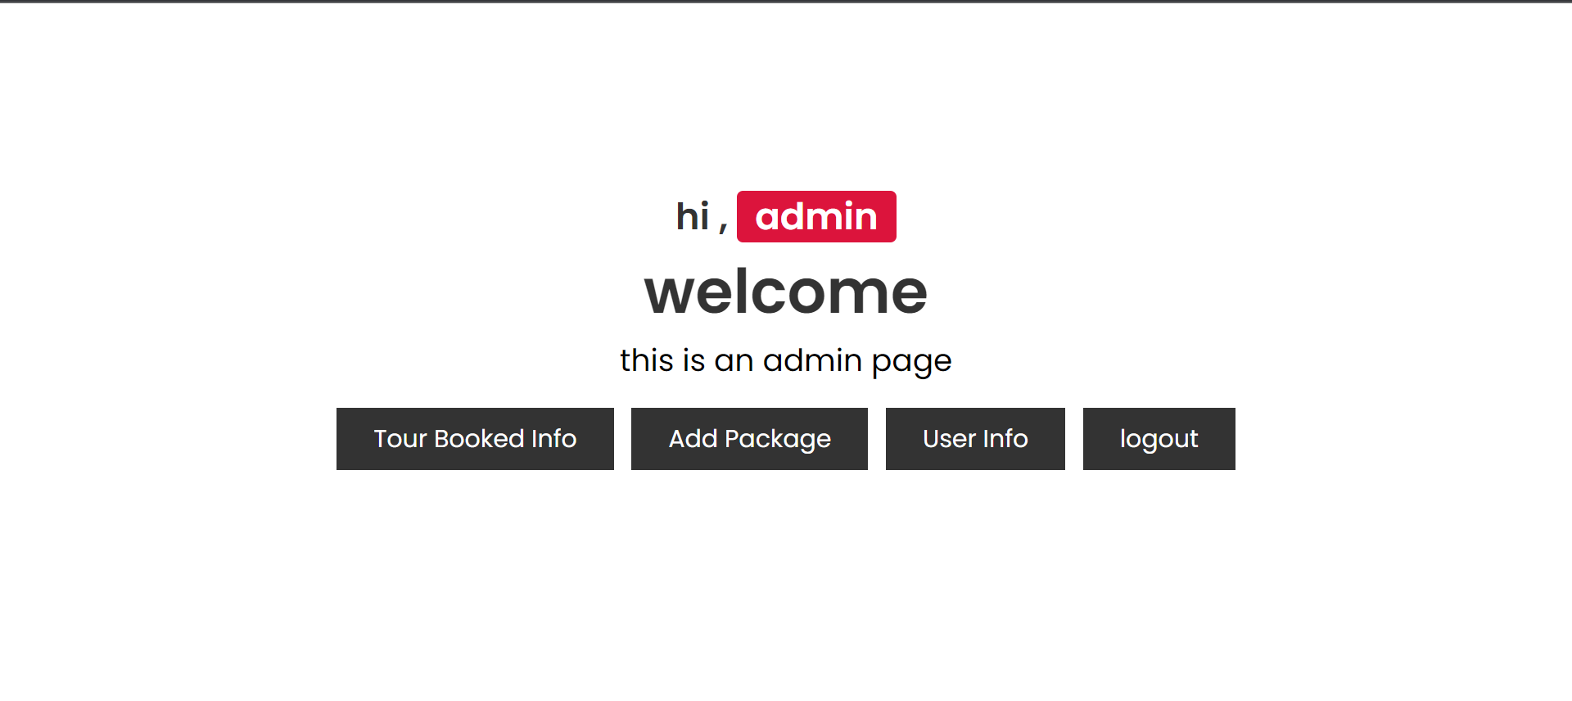

Admin manage products:

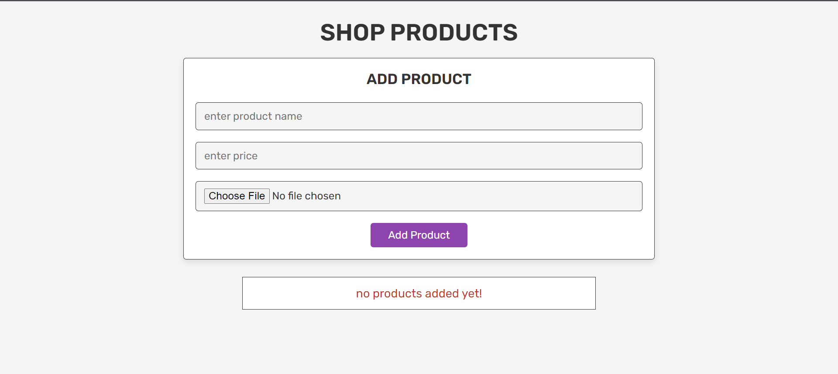

Manage Product:

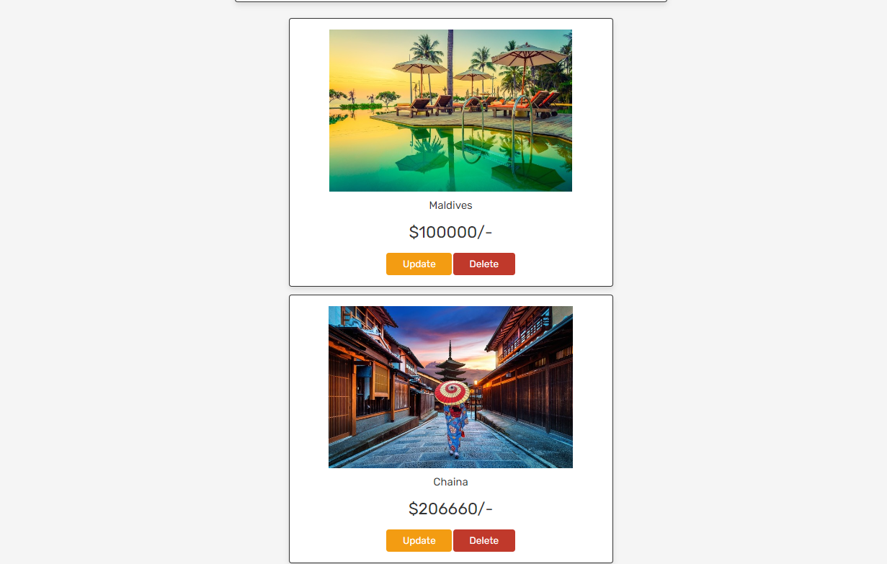

Booked Details of users:

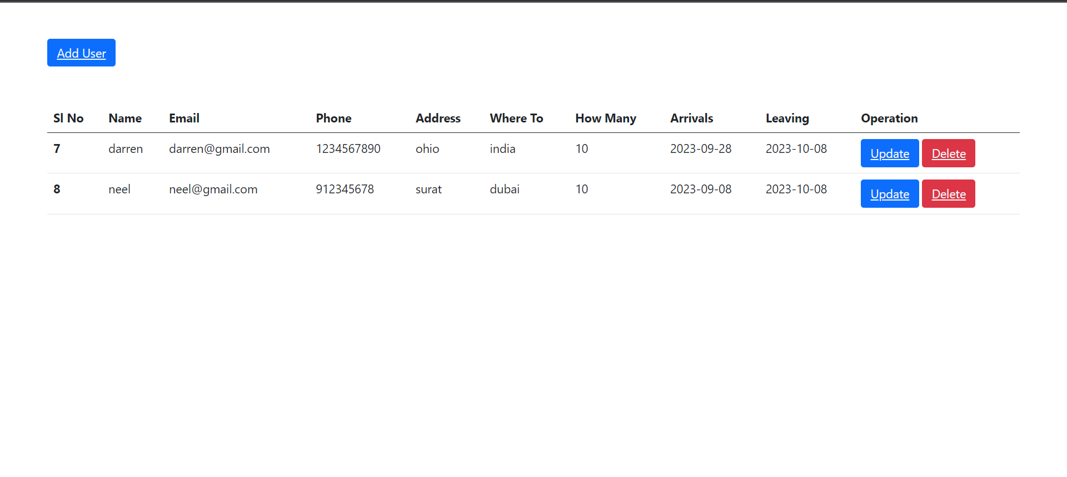Book Now page:

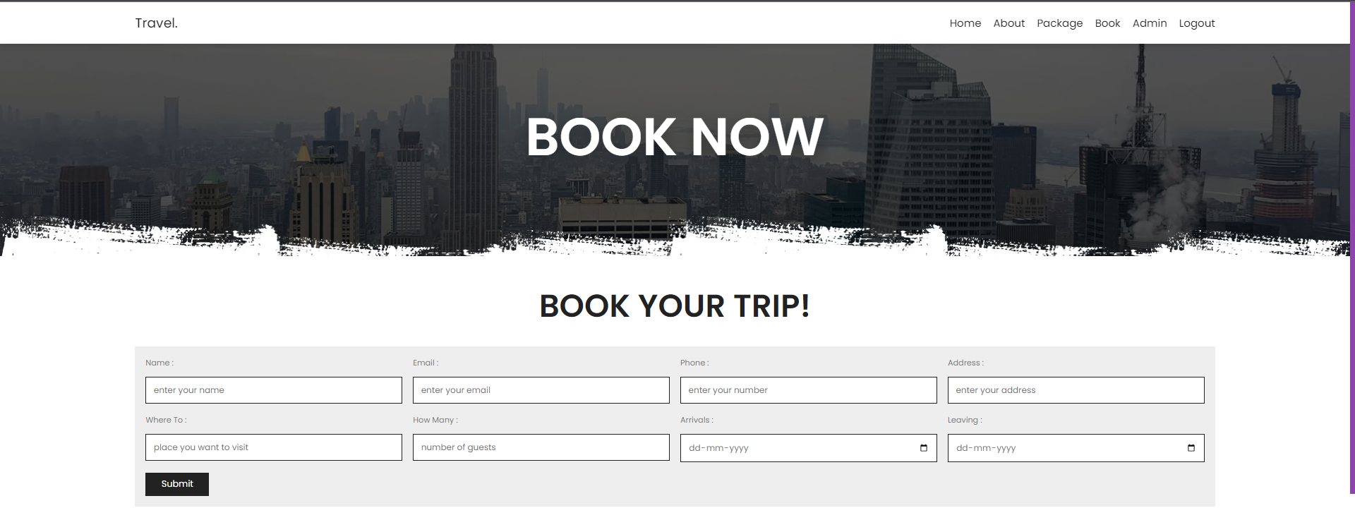

**Home page of user:**

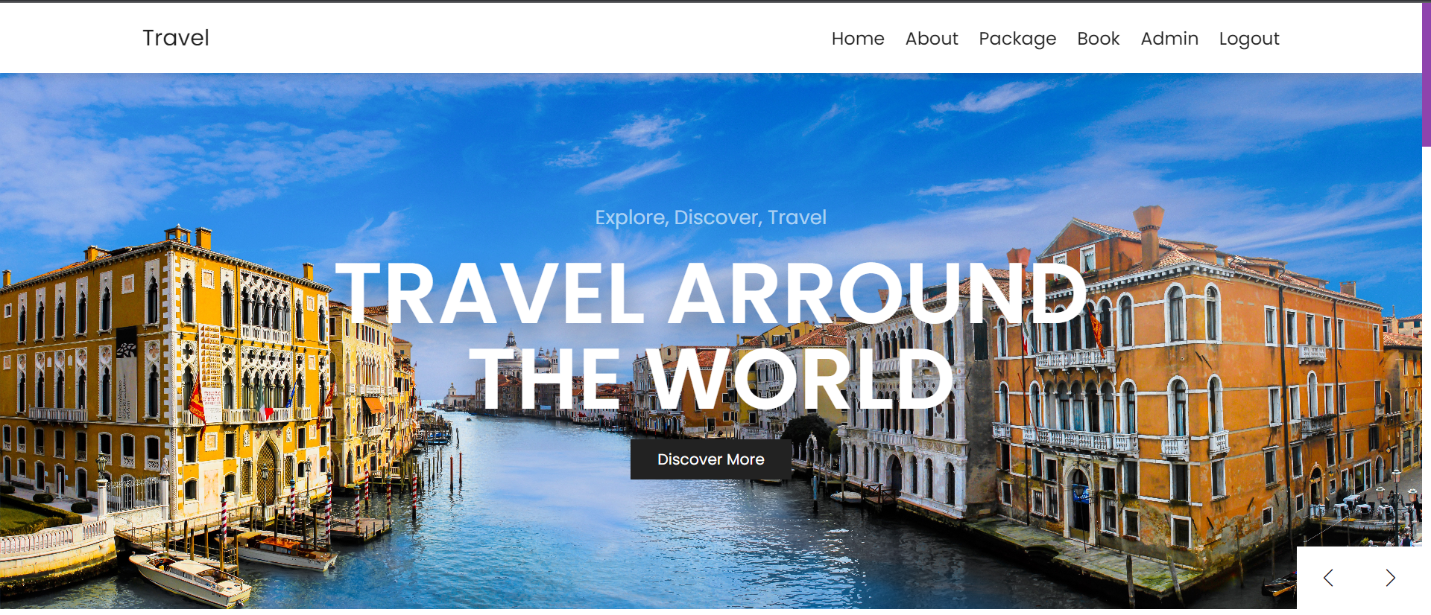

**Package Page of user:**

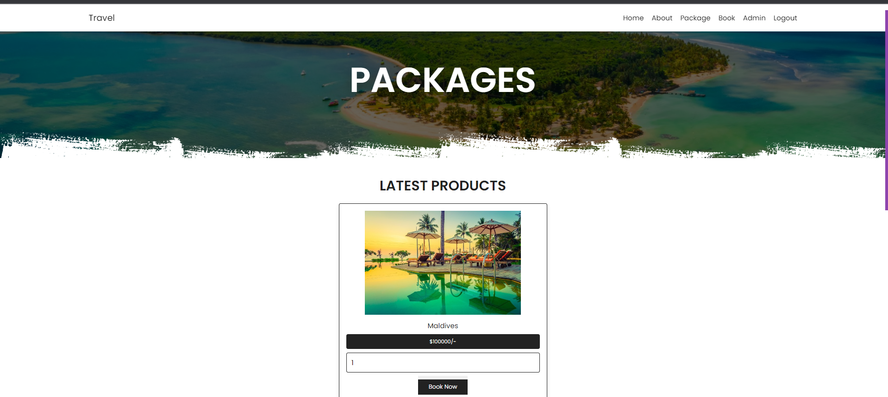

**Reference:**

[www.youtube.com](http://www.youtube.com)

[www.webdesigner.com](http://www.webdesigner.com)

[www.google.com](http://www.google.com)

[www.booking.com](http://www.booking.com)